Kanokphan Sirithienthong 6610750092

Step 1: Create a New Project. Name the project as Kanokphan_6610750092
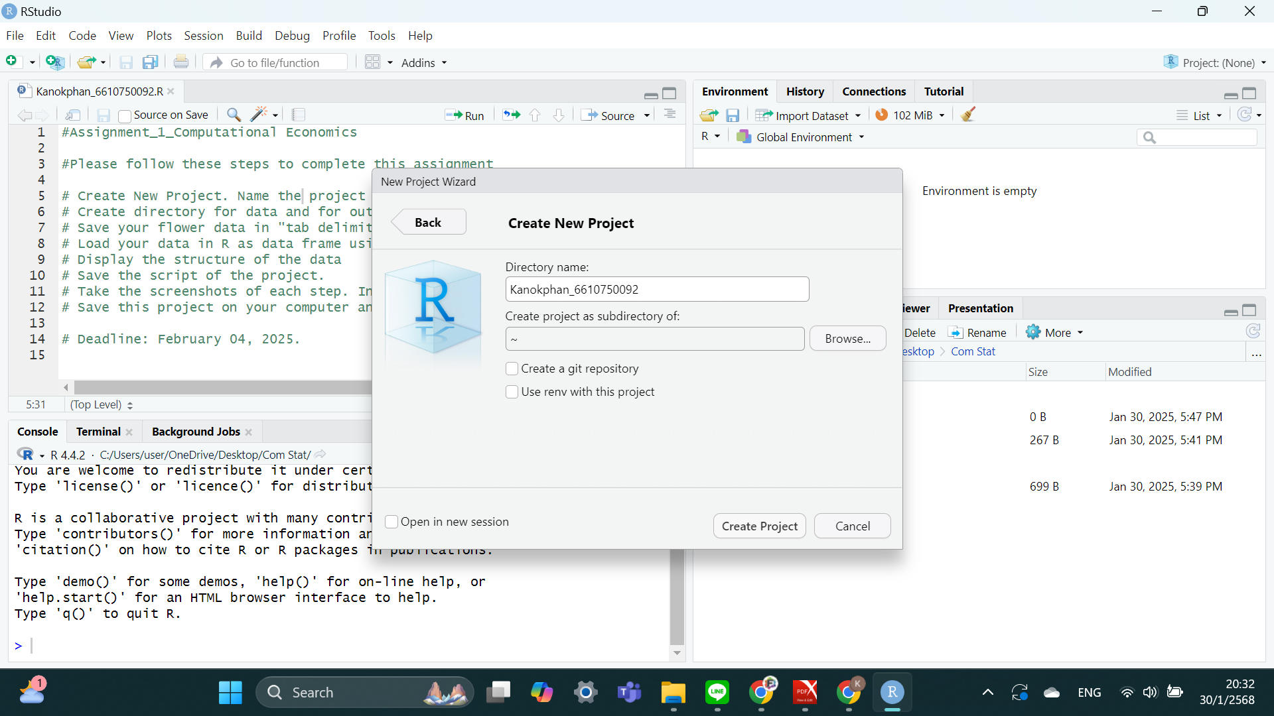

Step 2: Create directory for data and for output

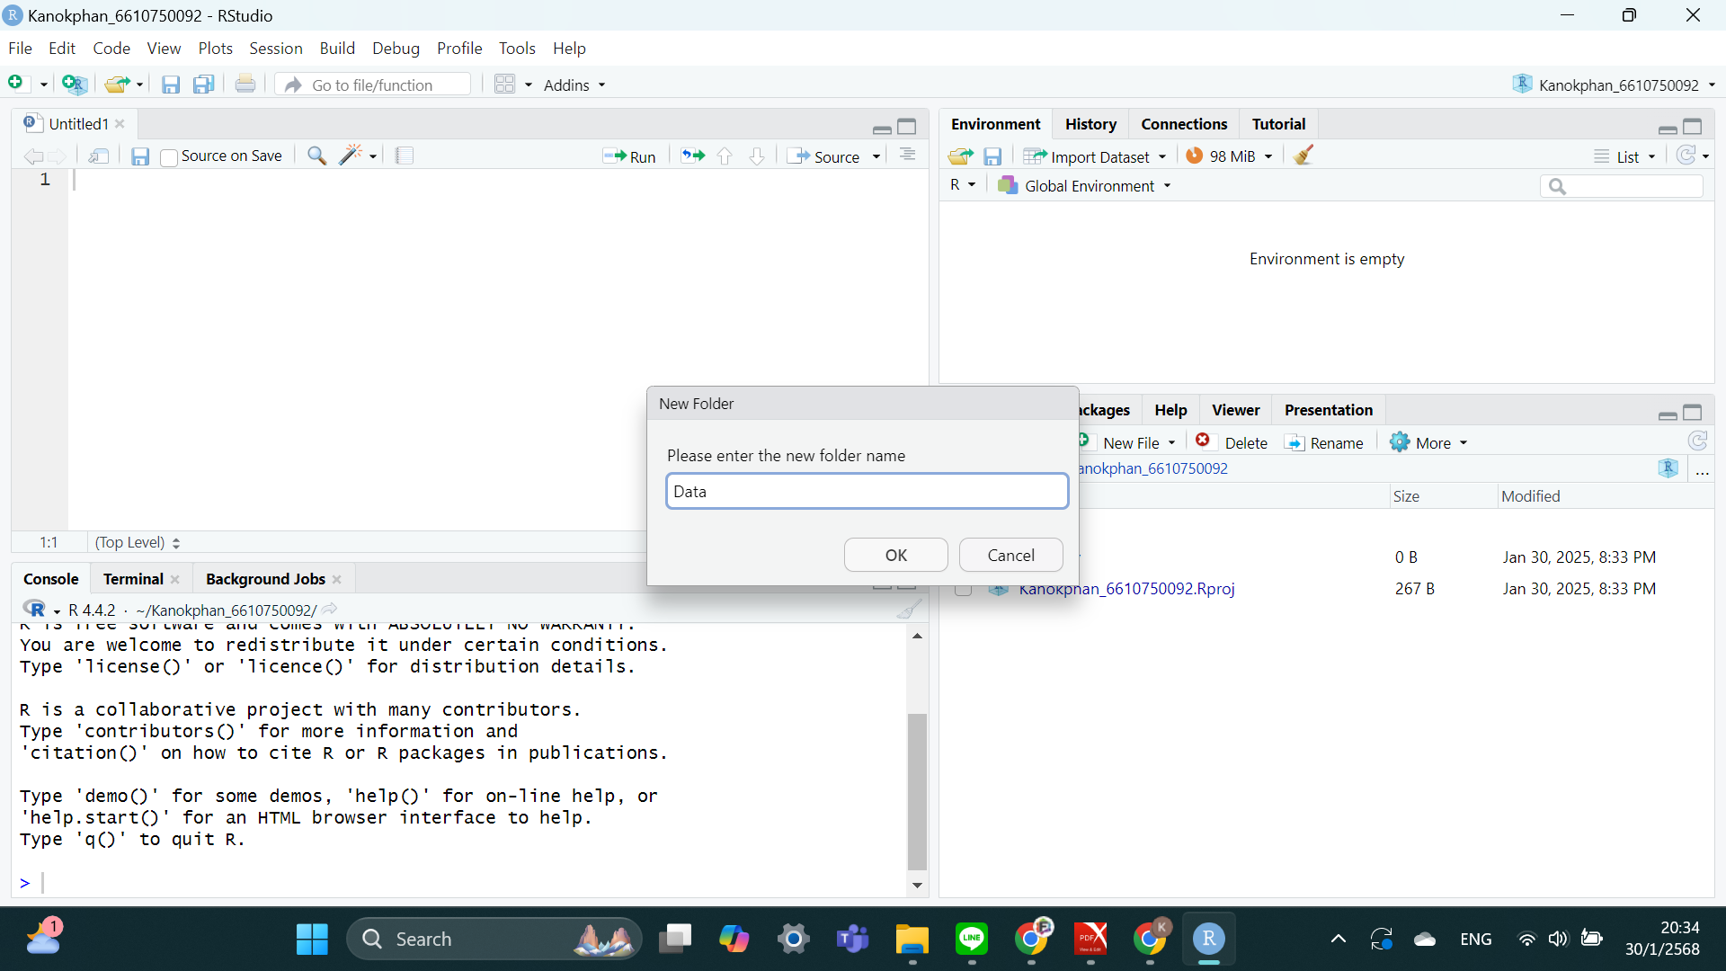
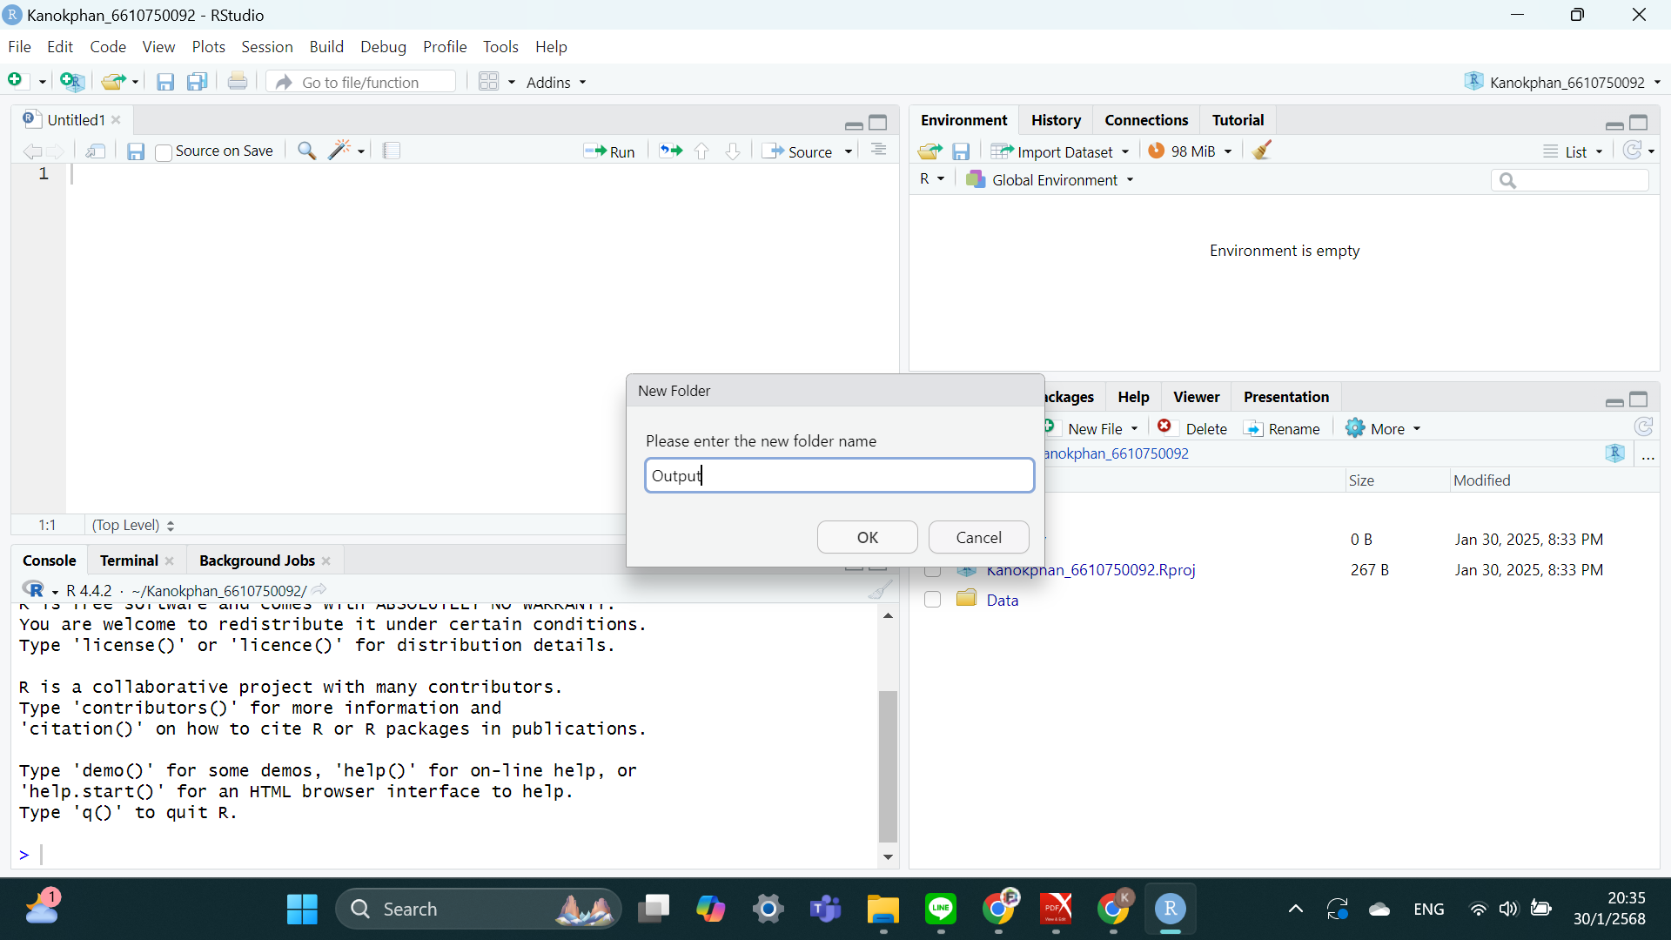

Step 3: Save your flower data in “tab delimited file” format with .txt in the data folder

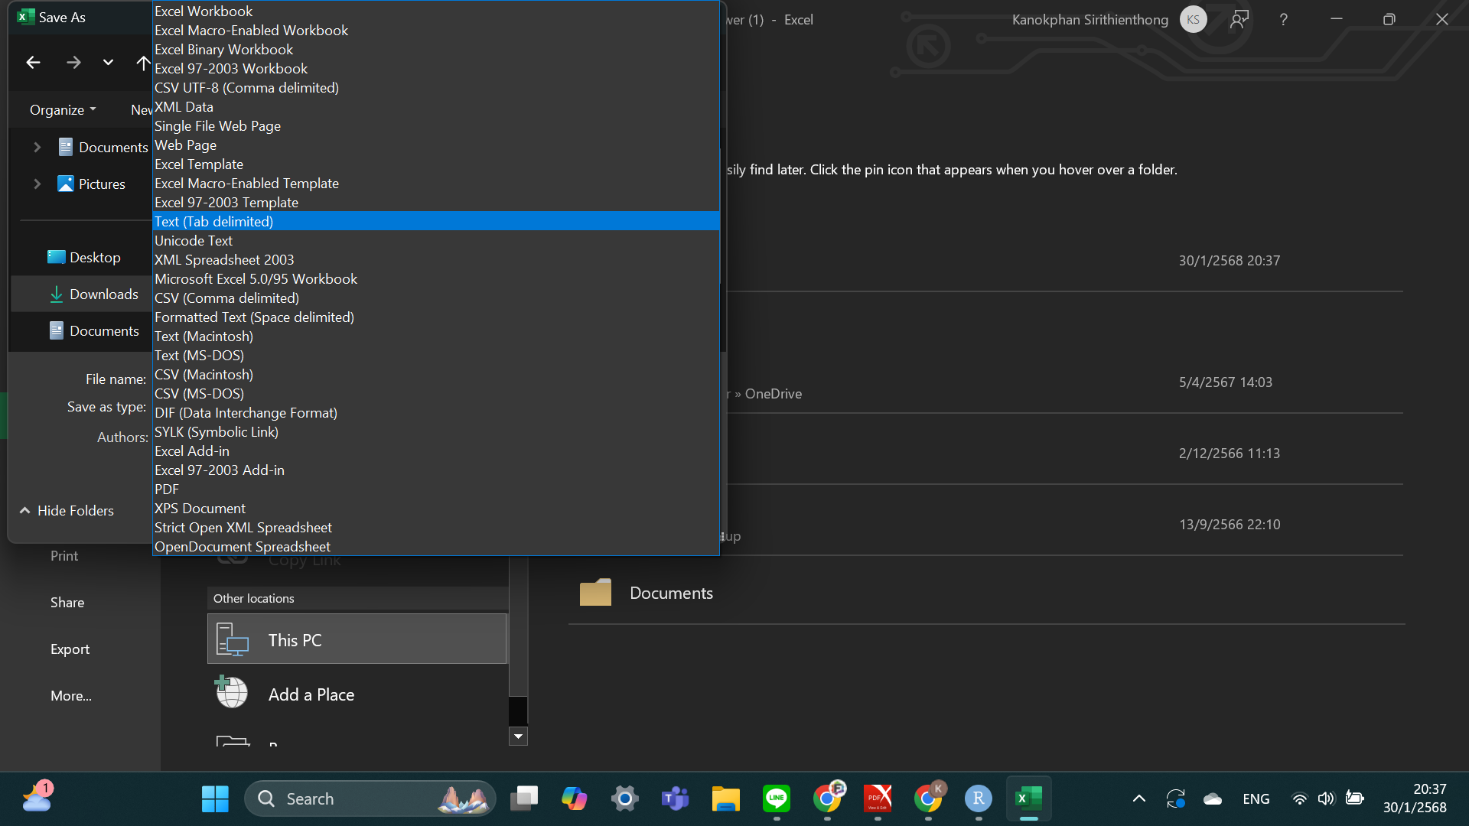

Step 4: Load your data in R as data frame using read,table function

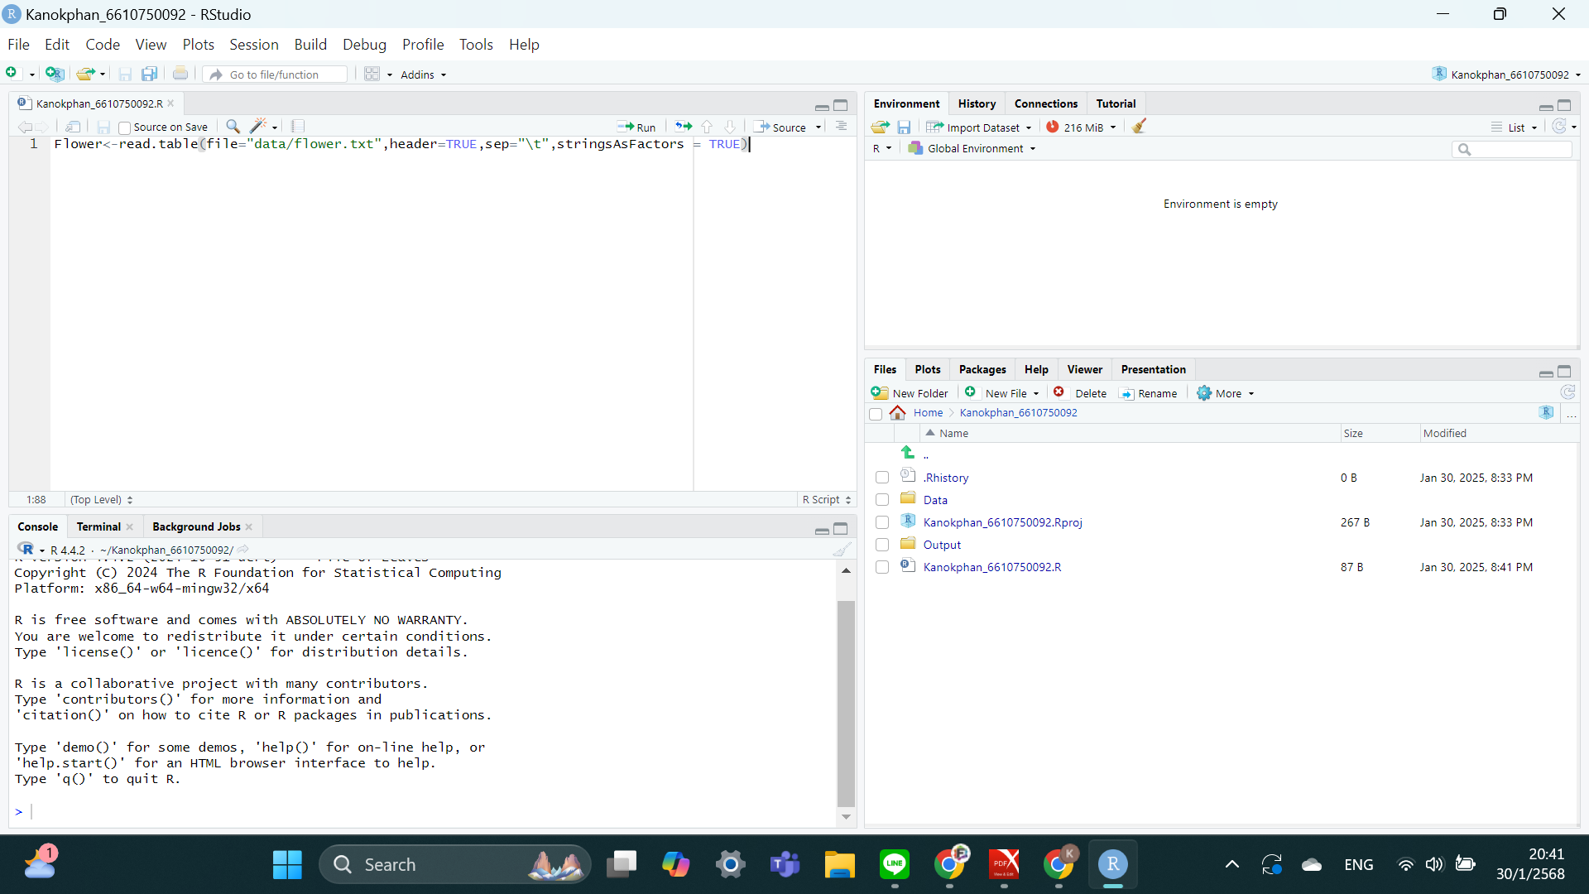

Step 5: Display the structure of the data

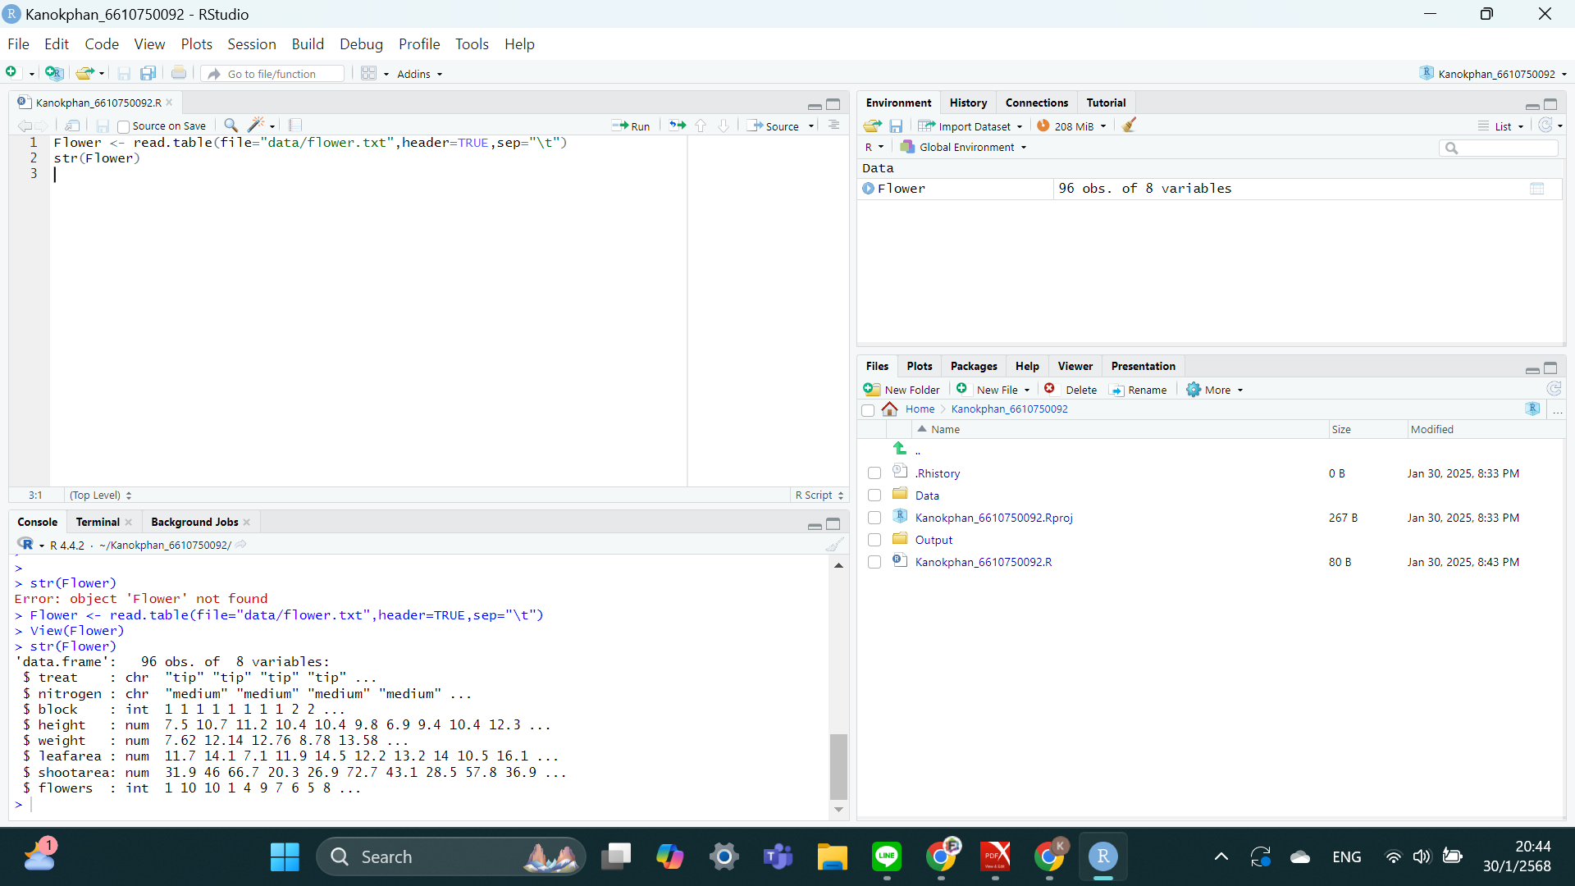

Step 6: Save the script of the project

